HOW TO ADD THE ILN IMAGE
TO YOUR BUSINESS E-MAIL SIGNATURE LINE

Big idea:
An email signature, such as your contact information or favorite quote, is automatically added at the end of your Gmail messages as a footer. Why not use a portion of this space to share information about the ILN?

Directions:
- Open your Gmail account.
- In the top right, click Settings “Settings”.
- In the "Signature" section, add your signature text in the box. If you want, you can format your message by adding an image or changing the text style.
- In order to add the ILN image, visit https://ea.ieee.org/ea-programs and click on “ILN Social Media Post Image (JPG)”. The image will appear in a separate window. Right click the image and click on “Copy Image”.
- Return to the Gmail Signature section and place your cursor in the space where you would like to add the ILN image. Then, right click and select “Paste”.
- The ILN image will appear in your signature, but it will be quite large. Right click on the image again. In the bottom left, you will see image sizes appear. Select “Medium”.
- To hyperlink the image, highlight the image, click the hyperlink button , and type in iln.ieee.org.
- If you would like to add text, you may use the following text above the image: “Visit the IEEE Learning Network today!” This can also be hyperlinked. In order to do so, highlight the text and click on the hyperlink button . Under “To what URL should this link go?”, type in iln.ieee.org.
- Once you review your signature line and are satisfied with its appearance, be sure to click on “Save Changes” at the bottom of the page.
- To confirm that your new signature is working, click on “Compose email”. Your new signature line should appear.

This is an example of the final product:
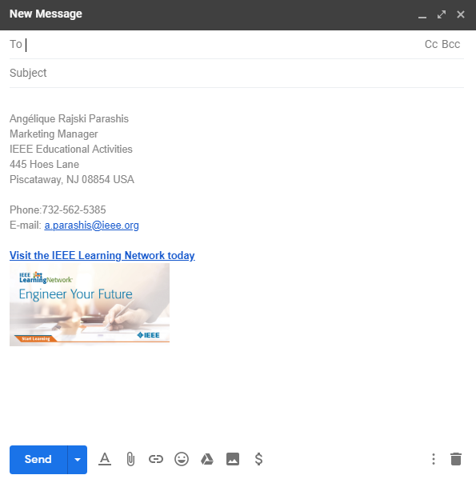

Thank you for helping us to promote the ILN!
Please do not hesitate to contact us with any questions along the way.
You may reach us at ilninfo@ieee.org.

